Que 1) Plot a histogram,

10, 13, 18, 22, 27, 32, 38, 40, 45, 51, 56, 57, 88, 90, 92, 94, 99

**Ans**

Bin size =Number/Bins

Bin size=100/10=10

Que 2) In a quant test of the CAT Exam, the population standard deviation is known to be 100. A sample of 25 tests taken has a mean of 520. Construct an 80% CI about the mean.

**Ans**

population standard deviation=100

n=25

sample mean=520

CI=80

SIGNIFICANCE VALUE=1-0.8=0.2

LOWER LIMIT=POINT ESTIMATE-MARGIN OF ERROR

LOWER LIMIT=SAMPLE MEAN – Z(0.1) x SD/ $\sqrt{n}$

Z(0.1)=1.29

LOWER LIMIT=520-1.29 x 100/ $\sqrt{25}$

LOWER LIMIT=494.2

UPPER LIMIT=520+1.29 x 100/ $\sqrt{25}$

UPPER LIMIT= 545.8

Que 3) A car believes that the percentage of citizens in city ABC that owns a vehicle is 60% or less. A sales manager disagrees with this. He conducted a hypothesis testing surveying 250 residents & found that 170 residents responded yes to owning a vehicle.

1. State the null & alternate hypothesis.
2. At a 10% significance level, is there enough evidence to support the idea that vehicle owner in ABC city is 60% or less.

**Ans**

Ho<=60 Null Hypothesis

H1>60 Alternate Hypothesis

(One tail test)

pᶺ=x/n=170/250

z score=pᶺ-po/ $\sqrt{po x qo/n}$

z score=0.68-60/ $\sqrt{\begin{aligned}60 x\frac{40}{250} \\ \end{aligned}}$

z score=2.581

Given CI=90%

Significance value= 10%

Z (0.9)=1.29

1.581>1.29

Thereforth we reject null hypothesis

Que 4) What is the value of the 99 percentile?

2,2,3,4,5,5,5,6,7,8,8,8,8,8,9,9,10,11,11,12

**Ans**

Percentile = 99/100 x(n+1)

Percentile = 99/100 x(21)

Percentile20.79=20th index=12

Que 5) In left & right-skewed data, what is the relationship between mean, median & mode?

Draw the graph to represent the same.

Ans

(Mean-median)=1/3(mean-mode)

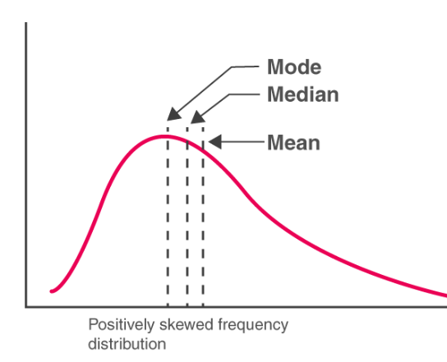

* **Mode<median<mean**

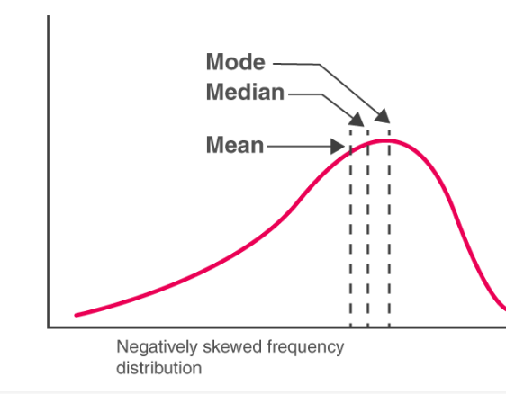

* **Mode>median>mean**